Circuit Analysis
Lab 4
Assignment

Submitted by:
Wardah Shahid
2025-CE-81

University of Engineering
and Technology

Task 1:

Circuit:
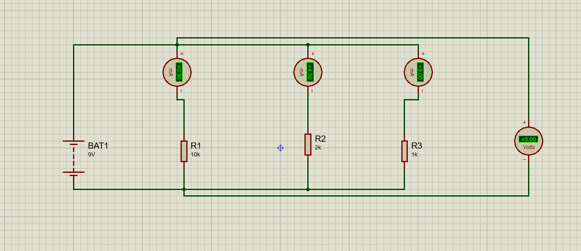
Explanation:
- This circuit is a parallel circuit powered by a 9V battery. Three resistors (R1 = 10kΩ, R2 = 2kΩ, and R3 = 1kΩ) are connected in parallel between the same two nodes.
- First, I connected the positive terminal of the battery to the top node and the negative terminal to the bottom node, creating two common nodes for all branches. Then, I connected each resistor in a separate branch between these two nodes.
- To measure the current, I placed an ammeter in series with each resistor. The measured currents are:
- Current through R1 = 0.90 mA
- Current through R2 = 4.50 mA
- Current through R3 = 9.00 mA
- To measure the voltage between node 2 and node 7, I connected a voltmeter across the two nodes. The measured voltage is 9V.
- This shows that in a parallel circuit, voltage is the same across all branches, but current varies depending on resistance (lower resistance gives higher current).
Table:
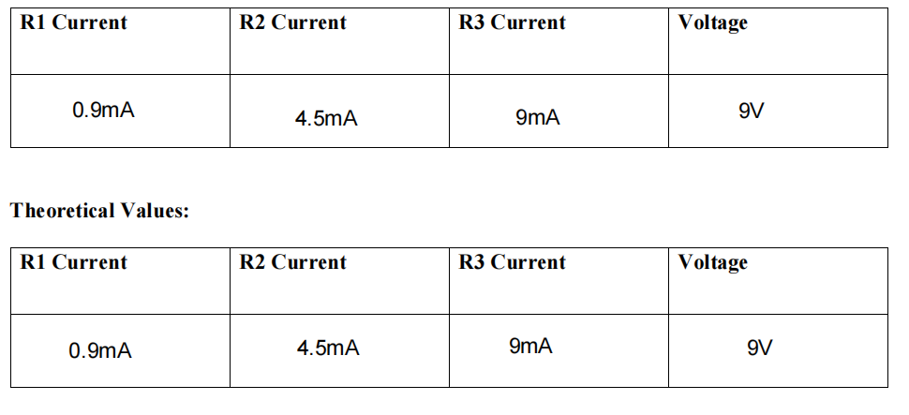

Task 2:
Circuit:
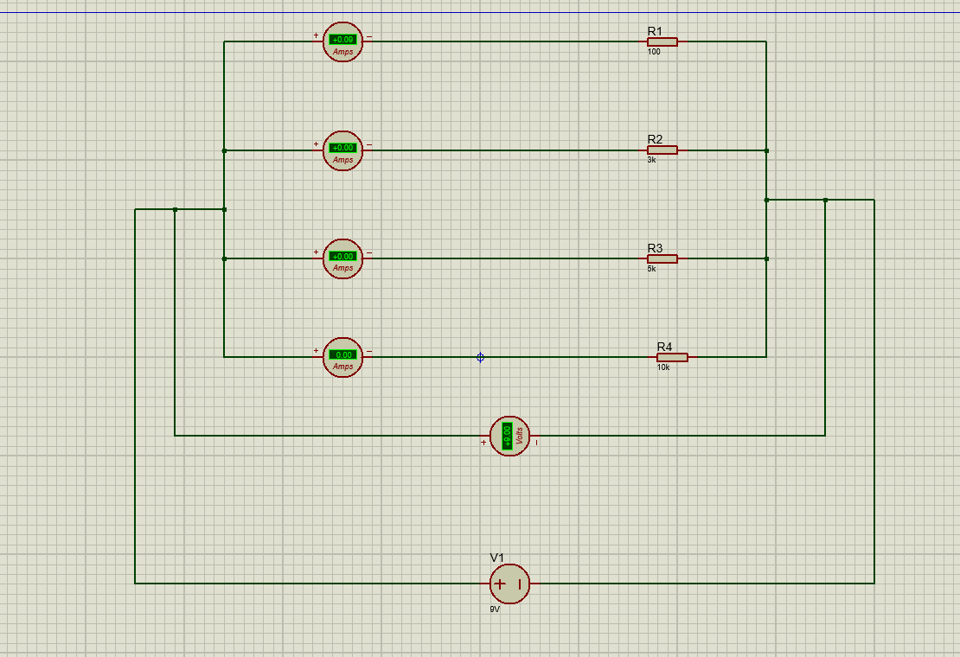

Explanation:
• First, I connected R1 = 100Ω, R2 = 3kΩ, R3 = 5kΩ and R4 = 10kΩ in parallel between node a and e
• Then, I connected a 9V DC battery across the circuit
• After that, I placed ammeters in series with each resistor branch to measure current
• Then, I connected a voltmeter between node a and e
• After completing the circuit, I observed that the voltage across each resistor is 9V
• Then, I calculated current using I = V/R
• I calculated I1 = 9/100 = 0.09 A (90 mA)
• I calculated I2 = 9/3000 = 0.003 A (3 mA)
• I calculated I3 = 9/5000 = 0.0018 A (1.8 mA)
• I calculated I4 = 9/10000 = 0.0009 A (0.9 mA)
• Finally, I observed that current is highest in R1 and lowest in R4 and total current is the sum of all branch currents
Table:
